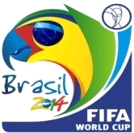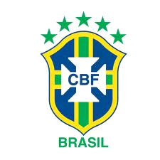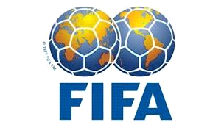

COMING FROM THE DESK OF THE PROMOTION MANAGER, INTERNATIONAL PROMOTIONS / PRIZE AWARD DEPARTMENT

FINAL NOTICE OF AWARD NOTIFICATION
We are pleased to inform you of the announcement of the 5th day of June 2013, the winners of the MEGA FORTUNE LOTTO BRAZIL/INTERNATIONAL PROGRAMS,
As part of our promotional draws.

Participants were selected through a computer ballot system drawn from 2,500,000 e-mail addresses of individuals and companies from Africa, America, South America, Asia, Australia, Canada, Europe, Middle East, and New Zealand as part of our electronic business Promotions Program.

You qualified for the draw as a result of your visiting various websites we are running the e-business promotions for You/Your Company, attached to ticket number 100-311-7482, with serial number BR613 -10 drew the lucky numbers 9, 6, 12, 29, 30, 45, 66, and consequently YOU HAVE won in the Second Category.

Your winning Ticket Number is: 100 -311- 7482
Your Serial Number: BR613-10
your lucky draw Numbers are: 3, 7, 17, 25, 31, 42
Your Bonus Number is: 11
Your INSURANCE Number is: LP3/7509.LTBR

You have therefore been approved for a lump sum pay out of US$820,000.00 in cash, which is the winning payout for Second category winners. This is from the total prize money of US$5,740, 000.00 shared among the seven international winners in the Second category. CONGRATULATIONS!!
Please be informed that your fund you won is, US$820,000.00 (Eight Hundred & Twenty Thousand US Dollars Only), is now deposited with the Omega Crossing Finance and Security Company insured with your email address which won you this prize, so we would like you to contact your agent with your full names so that they will re-insure your money with your full names.

Due to the mix up of some numbers and names, we ask that you keep this award strictly from public notice until your claim has been processed and your money remitted to your account. This is part of our security protocol to avoid double claiming or unscrupulous acts by participants of this program. To begin your claim, please contact your claim agent in the South Africa (SA) immediately;

MR. JOHAN NESPRY
FOREIGN SERVICE MANAGER,
OMEGA CROSSING. SOUTH AFRICA
STREET ADDRESS: 31, BRITON COURT,
KEMPSTON PARK, JHB. SOUTH AFRICA
Phone: +27745699141, + 27 847 400 149
jonesmegafortune@yahoo.co.za
1. Full Names:
2. Country:
3. Contact Address:
4. Telephone Number:
5. Fax Number:
5. Marital Status:
6. Occupation:
7. Date of birth:
7. Gender:
Call the above mentioned person for urgent processing and the immediate payment of your money

Remember, you must contact your claim agent not later than two weeks, of which this message was sent to you. Thereafter, all funds will be returned as unclaimed.
NOTE: In order to avoid unnecessary delays and complications, please remember to quote your reference and batch number and other information provided above and below in every one of your correspondences with your claim agent.

REFERENCE NUMBER: FLS-BR39-825P- 4
BATCH NUMBER: 74-263-BRNL

Contact your claims agent, Omega Crossing Finance and Security Company through phone or through his
Email address: jonesmegafortune@yahoo.co.za

THIS MEGA FORTUNE LOTTO BRAZIL PROGRAM, IS A BONUS FOR THE WHOLE WORLD FOR THE 2014 FIFA WORLD CUP BRAZIL

Congratulations'' once again from all our staff and thank you for being part of our promotional program.

Sincerely,

MR. MERVIN HAROLD
THE PROMOTIONAL MANAGER,
MEGA FORTUNE LOTTO BRAZIL.
Esplanada dos Ministries, Block B, 4th floor
Postal code: 70068-900
Brasília – DF
Brazil
MEGA FORTUNE LOTTERY BRAZIL
GOES INTERNATIONAL AS THE
2014

FIFA WORLD CUP WILL BE HOSTED BY
BRAZIL

“THIS PROGRAM IS SPONSORED BY: BRAZILIAN LOTTO AUTHORITY, FIFA PARTNERS AND FIFA WORLD CUP SPONSORS”

